**33 - HOME IN GRANTSVILLE AT GRANTSVILLE STAKE FARM, SOUTH WILLOW – MAR 1980 TO JUNE 1984**

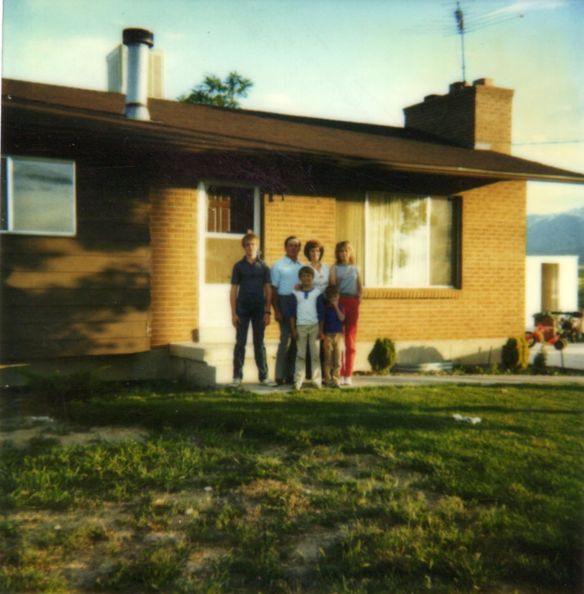

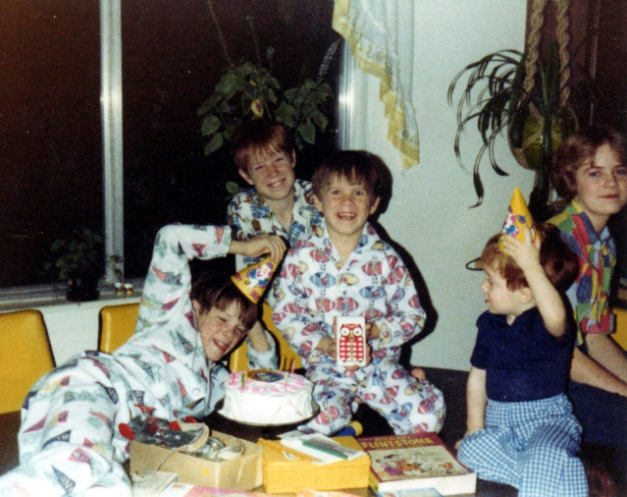I was excited to move back to Utah. I like Arizona, but I missed being close to our daughter, Sandi, Dave and our granddaughter, JaNae. I also missed living close to our parents, brothers, sister and their families. and able to visit them and go to the family activities and holidays - Thanksgiving, Christmas, etc., and I was excited to be back on a farm where the children could work with their dad and learn the value of work and also have fun because there is lots to do on a farm – not just work, but play too. The farm had a nice home on it as well as a chicken coop, place for a large garden, fruit trees, etc. It was a mile up a dirt road to the farm, but it was pretty with trees on both sides of the road with a creek giving them water. I had loved Erda and felt I would love Grantsville also, and I hope Ken and the children would also.

**“Amy” -** I had gone to the doctor several times when we lived in Mesa, Arizona and was concerned that this baby wasn’t as active as my other babies had been. The doctor always assured me that this was probably a petite little girl and that she was fine. When we moved to Grantsville and I went to a doctor in Salt Lake, I found out that the baby was not “fine”. He couldn’t get a heartbeat so he took an ultra sound and found the baby was dead. That was devastating to me and also to the rest of the family. He told me that I would probably just sluff it off in a few days, but he wanted to see me every other day and take a blood test to make sure I would be alright. After about two weeks he decided to do a D & C. Since the baby was dead, he felt it had shrunk so he didn’t give me anything for the pain. He just started the labor. It was a little girl and she had water on the brain so her head had grown very large and she came breach. It was very painful, in fact, the most pain I have ever been in and I went into shock. I was convulsing. They kept piling on warm blankets, but I was shaking uncontrollably. I finally recovered, but was angry with the doctor that he hadn’t given me anything for the pain even when I asked for it. Since the baby was dead, I didn’t know why they couldn’t give me a shot or something.

When I went in for my six week’s checkup he said I was in every good condition for a woman my age and that if we wanted a baby, we should send for it right away. We were so disappointed over losing “Amy” that we decided to try again. I did get pregnant, but lost it at 3 months. I went into such a depression that Ken was really worried. When I went into him again for my six-week checkup, he again said it was a “fluke” and that I should try again. I told him that I would raise the 6 children I had because if I got pregnant again and lost it, I was pretty sure they would lose me. I was upset that he would even suggest that again. I didn’t realize it until later, but Shellie & Jeff grieved over losing Amy as they really wanted a little sister.

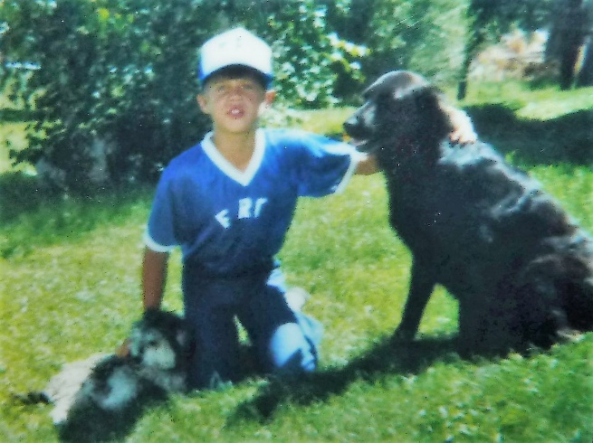When we were leaving Arizona the 2nd time and were moving to Grantsville for Ken to manage the Grantsville Stake Farm, Larry & Tammy had a dog named **Naunoo.** He was a black lab and since he was large and black and it was hot in Arizona, they asked if we would take her with us to Utah. It was Lonnie’s dog and he hadn’t wanted to give her away, but his dad convinced him that Naunoo would be much better off and much happier on the farm, so Lonnie told us “Please don’t change her name – her name is Naunoo. We promised him we wouldn’t. Naunoo did love the farm and our family and we loved her. She was so affectionate and fun to be with. Jeff was just a little guy only a year and a half old when we moved to Grantsville so he grew up with her – at least for the first few years. All of us loved Naunoo, but especially Jeff. We had a tom cat which we loved too and when the boys would take their guns to go in the fields to kill Starlings, Naunoo and Tom would go with them. Ken allowed them to shoot these birds as they were a messy bird that would get into the farm buildings and make messes all over everything. When they would shoot a bird, Tom was right there to get it and eat it. One time the bird was falling and then recovered and was about to fly away when Tom jumped so high and grabbed the bird with its claws. Sandi & Dave lived not far from us in Grantsville and they had a dog named **“Penny”.** Dave brought it over to Ken and asked Ken if he would kill it for him as it’s back was broke and it was suffering. Dave was a mighty hunter, but he wouldn’t shoot this dog. We found out later that he had been mad at the dog and kicked it with his boot and that was the problem. The children saw Penny and loved her right away and talked their dad out of shooting her that night. They doctored her, cared for her and gave her lots of attention and she was much better the next day so they asked if we could keep her. Ken gave in and we did keep her. She was such a cute dog too. Her and Naunoo became good friends. Penny was black too, and you would see the big black dog with the small black dog following her around. Ken used to go to Grantsville for equipment, supplies, materials, etc., when they had them there rather than have to go to Salt Lake. Many times, he would be going to a neighbor, or to Vern Pankratz, who was the farm manager in Erda and whenever he went out to the truck, Naunoo & Penny would follow him. Naunoo would jump in the back, but Penny was too little, but wanted to go too so Ken would lift her in. One day, he was in a hurry and didn’t notice Penny. Naunoo had jumped in and Ken started the truck and started down the lane. Penny stood there looking surprised and then started off after them. She ran & ran, but couldn’t catch them. She stopped, looked around at me, then starting running after the truck again. Finally, she realized that she couldn’t catch them, so she turned back around and started trudging back up the road with her head hanging down. She was so sad. It made me sad to see her like this. I told Ken and he laughed, but felt bad too. The next time, she tried jumping into the truck and she tried several times and finally made it. After that, she always jumped into the truck herself. She wasn’t going to be left behind again. There were skunks on the farm and Naunoo would kill them. She would corner it in the field and it would try to spray her, but she would run so quickly around it that it could stand still long enough to spray her, finally Naunoo would grab it by the neck, give it a quick, hard shake and toss it. It would break the skunk’s neck. He did this many time, but one time she wasn’t quick enough and the skunk got her. She couldn’t understand why we wouldn’t let her close to us and we would throw rocks at her to keep her away. A few days later when it was bearable to have her closer, we washed her with tomato juice and that helped.

I will attempt to give a **brief summary update of the Kenneth H Browning family** from the time we lived in Grantsville, Utah on the Grantsville Stake Farm which was at the time I had the privilege of complying the Byron Porter Family Descendants book. The books were sold at our Porter reunion on July 4, 1983.

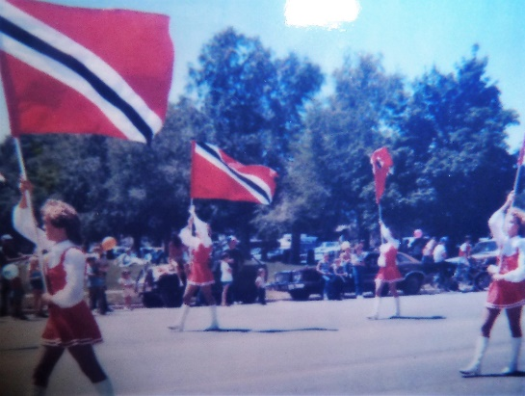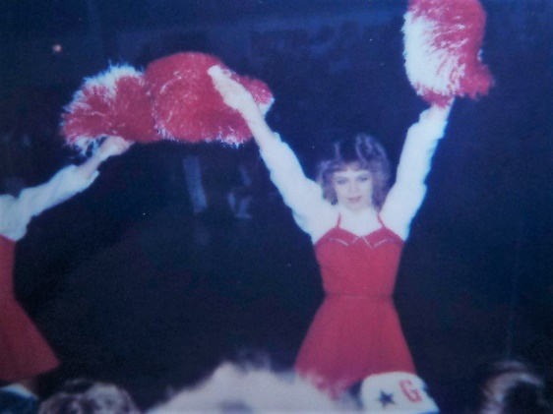The farm was great for our 4 sons. **Shellie** wasn’t so sure she liked it when we first moved there, but was happy to be close to her sister, Sandi again. At first Shellie had a hard time making friends, and the friends who accepted her were not the best kind. She didn’t feel comfortable with them, but needed friends. I was concerned and talked to Jeanie Burgess, a friend in our ward, as she had a daughter, Becky, who was Shellie’s age, about her and Shellie becoming friends. It turned out that one day when Shellie went to lunch, her friends were not there and she saw Becky and some other girls sitting close by eating lunch so she went over and asked if she could eat lunch with them. She enjoyed them and they were friendly to her. When her other friends came in and asked her to come over with them, she declined. From that time on, she left the former friends and stayed with Becky and the other girls. She was much happier. **Shellie soon enjoyed it as she became a flag twirler for the band in high school and a cheerleader**.

One incident I will insert, was after Shellie got her driver’s license and she had to drive our station wagon some times. One winter day, she took Jeff with her (Jeff was only 5 years old, but very perceptive and had the spirit guide him, even as young as he was). There were two dirt roads coming up to the farm. The main one we drove was tree lined and beautiful, the other was further west and more barren, but some farm land. Shellie was starting to drive down the main one when **Jeff said excitedly “No, don’t drive down this way, go the other way.**” Shellie couldn’t see why he should say this and she was in a hurry, so she brushed it aside, even when he kept telling her to not go down this road. It wasn’t long until she saw a pickup truck coming up the road. There wasn’t much room to pass, especially since there was lots of snow. She tried to put on the brake, but the roads were slippery and she slip into the truck. He had tried to stop also. Well, she totaled out the station wagon. She told me later that she thought her dad would be really angry and upset with her, but he was patient and kind and she said she was sure thankful, but she wished she had listened to Jeff. I remember having Jeff with me one night as we were going down a dark, lonely road. Jeff said “Mom, don’t go down this road.” I knew to listen to him, so we turned around. I don’t know what would have happened, but probably something bad as that were the only times he said that.

**Mike and David** - they were a big help to their dad on the farm. One of their responsibilities was to change the water pipes to irrigate the crops. Shellie helped some too. They had different experiences with moving the pipes. Sometimes they met up with snakes or mice or other critters. When the barley was high, all you could see was the sprinkler pipes moving as they walked along to change them. They also helped with most of the farming; at least all Ken felt they were capable of doing. One incident with Mike was when he was on the tractor baling hay. Ken saw the tractor just sitting out in the field, so he drove the three-wheeler over to see what the problem was. Mike told him that something was caught in it and so he shut off the tractor. Ken chewed him out and told him that he wasn’t to just sit there, but he was to get off and see what the problem was and see if he could fix it himself. Mike learned a good lesson from that which served him the rest of his life.

Another experience with Mike was when he was plowing and he was off the tractor getting a tool out of the toolbox which was fastened to the tractor. Mike felt something down by his leg and he saw a **gopher** which was chewing on his pant leg. He grabbed the hammer and hit it on the head. He thought he would take it home for Tom, our cat, to eat, so put it in the tool box, but when he opened the tool box to give it to Tom, it was alive and running around. David was there with Mike, so said “Let’s keep it as a pet.” Mike agreed so they got a five-gallon bucket, filled it with dirt and put the gopher in it. They checked it often to put food and water in the bucket for the gopher, and they played with it. Ken agreed that they could keep it. One day our phones wouldn’t work, so we called the repair man. He found that the line had been chewed through and that was the reason the phones wouldn’t work. The repairman asked if we had a dog or cat that might have done this. Mike & David hadn’t seen the gopher for a few days, so asked if it might have been it. We assumed that it was as we didn’t have our dog and cats in the house. The repairman had fixed the cord and was filling out his report and said “Well, I’m not going to put down that a gopher was a pet and had chewed it, I will just put down that it was a pet.” We all laughed about that.

I mentioned that our animals were farm animals and not house pets, but one time we had a mouse in the house, so we brought Tom in to catch and eat it, but he was so scared to be in the house that he wouldn’t do it. In Erda, we had a Tom there too (different Tom) and he was fat and lazy because we had a mother cat who was skinny because she would go out in the fields and catch mice and bring them back to feed Tom and her kittens. One day I was out hanging clothes on the clothes line and this cat was bringing in a mouse for the other cats or Tom, but when she saw me, **she ran over to me and dropped the mouse at my feet.** It was still alive and ran over my foot to try to get away. I jumped and screamed. The cat looked at me in surprise, ran and got the mouse again and took it over to Tom. I guess she was trying to be good to me by giving me the mouse, and she was disgusted that I didn’t want it.

The younger boys had chores and responsibilities also. **One incident I’ll mention which involved Scott** still scares me when I think of it. Scott was with his dad up in the fields and his dad told him **to drive the tractor down to the shop and park it there. Scott was only 7 or 8 years old, as I remember**. Ken showed him a little about the tractor and sent him on his way. Partway down the dirt road which had ruts in it, the tractor tire fell into one of the ruts and threw the tractor off the road and it was headed down into the field. It scared Scott, but he had presence of mind enough to shut the tractor off. He then jumped down off the tractor and came running as fast as he could to the house. When I found out what had happened, I was really upset with Ken that he would put such a young child on that tractor and have him drive it. Scott could have been really hurt. Ken tells me that his dad had him doing things like that at a young age, but I sure don’t agree with it. Ken had Jeff drive the 3-wheeler along as he worked on the wheel lines. I felt Jeff was too young, but Ken felt he could and needed his help. Jeff thought it was great.

**Mike and David were in the school marching band**. They both played the trumpet, but after a while the band leader asked Mike if he would play the sousaphone. It was a big instrument, but Mike was a fairly large boy so he was able to carry it and play it well. This band teacher, Mr. Jarvin or something was that, was excellent and so they had a great band. They had beautiful band uniforms and marched in parades, not just in Grantsville, but other places as well. I remember talking to Mr. Jarvin one day and thanking him for what a great teacher he was and how Mike & David enjoyed being in the band. I told him that they were both involved in sports also. He said “That’s good as music and sports work together and help the student do well in academics also.”

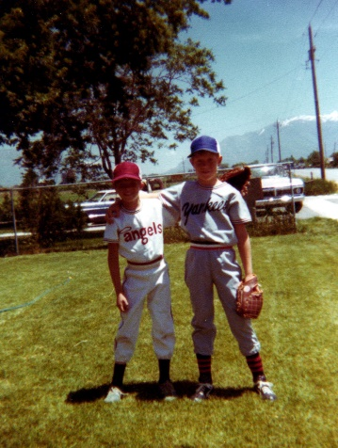**Mike and David played “Little League baseball”.** Ken was usually too busy on the farm to go watch their games, but I think I went to all of them. Both boys were on separate teams and both played “pitch” on their team. I would go to both of their games, but when the two teams played each other, I would sit and cheer for the one who was pitching, but when the brother on the other team was at bat, I would run around to the other team’s fans and cheer for him. The people thought it was funny watching me run back and forth. One-time Mike was pitching and David bating and Mike hit David with the ball and David got to walk. The crowds laughed about that. We lived in Grantsville for four years and so as the boys got older they played football and basketball. I remember David playing baseball for the church team. He was really good at it and I loved watching him. Baseball or softball is one of my favorite sports to watch, and it’s always much better if you have a son on the team.

One incident I will tell is one day when Ken and I went down to the Elementary School to pick up the kids. We parked in front and then we noticed that a **big kid was bullying Mike and pushing him around, out on the lawn.** I was about to jump out of the car and stop the kid, but Ken saw David coming out of the school door and said “Wait a minute, **let’s see what David does.”** Well. When David saw the kid pushing his brother around, he came running and like a wild cat, he jumped on the kid’s back and started hitting, clawing and kicking him. The kid had a hard time getting David off his back, but when he did, he took off running. That was something to see. David will sometimes get mad at Mike and they will fight or wrestle, but nobody better hurt his brother.

**Mike had to have an operation to have his tonsils out when he was 16.** There was another girl, who was also 16 who was just before Mike. When she was in recovery, she was crying, she wouldn’t eat popsicles, or drink anything, while Mike got along great and ate and drank the liquids they asked him to. He then was able to get up and go finish playing video games while he recovered. He had been playing them while he waited for his operation. The girl’s mother asked me how Mike was doing so well and her daughter was doing so bad and they were both the same age. I didn’t know, but I was proud of Mike.

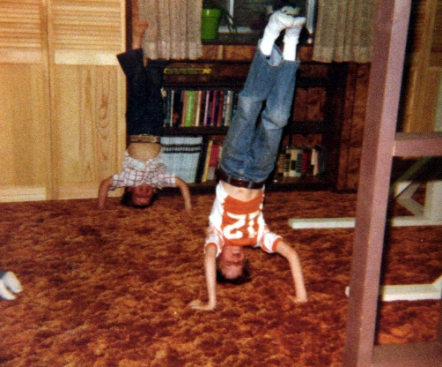**Scott and Jeff** were good boys and helped their father on the farm too, as I have mentioned. They also helped me. We had some fun family home evenings. One I will insert is when we held it on our roof. Ken was trying to explain that we don’t just have to sit on the chairs to have family home evening, but the one who is conducting can visit with the one giving the lesson and work out where they want to have it and how, as long as we are all together and enjoying being together. Our son, David, who was 10 years old asked: Then, can I have it up on our roof? Ken said “yes” and when it was time, he got out the ladder and I got a quilt and we all climbed up on our roof and had a wonderful time with songs, prayers, lessons, activity and refreshments. Although, I have to tell you that we were living on a farm at the time and our closest neighbor was ½ mile away. (This picture is of Scott & David standing on their heads.)

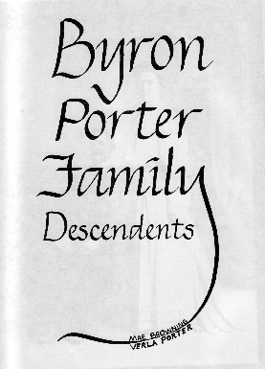**My Uncle Dale, my dad’s youngest brother, called one day to ask if I would be interested in putting together a “Porter” book**. Histories and genealogy of My Grandfather & Grandmother Porter, Byron & Mary Elizabeth (May) and their descendants. He said he knew I loved family history work, and if I felt I could, he would pay for me to go to the Family History Conference in Salt Lake that the church was sponsoring. He felt it would be helpful. He said he would finance the book and then after the completion, we would sell them at cost to family members. I agreed and was excited. The conference was helpful. It was a three-day conference. I stayed at our niece, Sheryl Bottom’s (Ken’s sister, Margaret’s daughter) home the two nights rather than drive back & forth. I enjoyed visiting with them each evening.

I contacted all our relatives both by mail & phone and asked them to submit a brief history of their family along with a family history sheet and family pictures. I set a deadline for them to get them in, but ended up setting several deadlines as everyone is so busy that it took a while to get them all in. In the meantime, I wrote my grandparent’s history and my Aunt Maurine and Uncle Royals who were deceased also. Aunt Maurine had written some of her history and also some about her parents. I also contacted each of the immediate family and asked them to write down things about their parents, sister and brother. Some felt that grandma had written a history, but we couldn’t find it. I prayed about it and before the book was printed, Aunt Beth found it at her home. I was very grateful. I had already put one together on her, but added hers. Grandpa Porter had written some on his life also - that I put in. It took me three years to complete this book and felt that was a long time, but when we took it to the printer (Stevenson’s in Prove - he is a relative) he said for a book that size he takes 10 or more years sometimes - so I felt better. I got it all typed in rough draft, but Verla, my cousin and Uncle Verle & Aunt Beth’s daughter, retyped it on her computer at work at BYU. That was a lot of work also and I sure appreciated her help. This was a wonderful time putting this together and inserting the pictures, family history sheets, pedigree charts, etc. I had a lady do the calligraphy which said “Byron Porter Family Descendants. This was a spiritual time and a joyous time. I felt closer to my grandparents and all they went through in this life, yet remained faithful. I grew close to my aunts, uncles & cousins because of their histories and working with them on this endeavor. Everyone seemed pleased with the finished product. We wanted the cost to be affordable so everyone could have one who wanted one. Uncle Dale gave me & Verla one and the family signed it at the reunion. I wanted one for each of my children and since the price was right, I was able to do it. We were able to only charge $4.00 a book because Uncle Dale paid a lot of the cost. Uncle Dale wanted to pay me for doing this from money he got when Uncle Royal died. Uncle Royal worked for Uncle Dale & Uncle Dale had him in a profit-sharing trust. Uncle Royal never married - so this money just came back to Uncle Dale. I told Uncle Dale to put that money towards the books also, as it was a privilege to be able to put together this book.

**In Grantsville, I was probably the most involved in community and volunteer organizations than I have ever been**.

A good friend in the ward talked to me about joining the “**Eagle Forum**” headed by Phillis Schaffley. Phillis is a lawyer and really concerned about the decaying morals and the evils in today’s world. She organized this organization that is now nationwide. She has paid lobbyists to lobby for the bills, etc., for the traditional family. She sends out a monthly letter informing us of the issues that she and the organization are fighting. She asks us to make others aware, send around petitions, speak out, send money to help the cause, send for more pamphlets to send to people, come to conventions, etc. I really feel strongly that she is an honest, inspired woman who cares about the constitution, children and the American family and is doing all she can - speaks everywhere - college campuses, congress, organizations and other women’s clubs, etc., etc. She is fighting for the right. She has a cause and at that time I did get involved and tried to do what I could. I still pay my dues each year and continue to get the newsletters, but am so busy with work, family, elderly mothers, church, etc., that many months I don’t even take time to read them. I wish I had more time to do more with it now too. It is a good cause.

I also attended the **“Freeman Institute” taught by Cleon Skousen** at Grantsville High. I bought several books from Cleon Skousen. He was trying to educate all of us on the constitution and the founding fathers, and what has happened to our constitution and what we can do about it. I felt that was a good cause also.

I wanted to insert a letter, but couldn’t find it. (2/06/2013) It was a great letter with Cleon Skousen praising Phyllis.

I also joined the **Women’s Republican Organization** and went to meetings in Salt Lake and local meetings. I volunteered to help at the County Conventions. I was a voting registrar and also a judge for the elections. I did this three of the four year we lived in Grantsville.

Nancy Regan (First Lady) organized **“Chemical People**”. She was really concerned about the youth and the rising problem of drug & alcohol addition, and the denial of the parents. She asked neighborhoods to come together and form neighborhood or city & town committees. We met at the city building. We viewed the televised program where she spoke and had other adults & youth speak. Then we were to elect a president and vice president, set goals and then work to accomplish the task before us. They elected Ken as the president and me as the vice president. We had a pretty good crowd there. We did set goals and formed a committee to meet regularly with us.

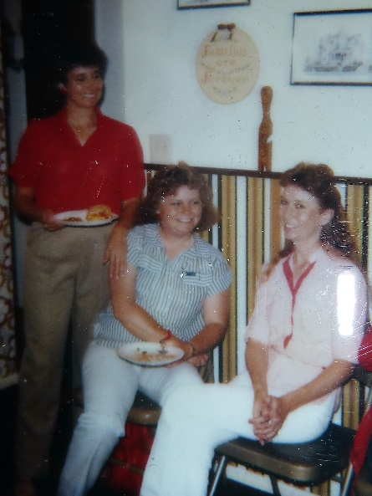**Michelle Killian** was the Stake YWMIA President. She lived in our ward, and she asked for me for her 2nd counselor. I don’t remember what positions I had served in the ward before being called by the stake for this position. Michelle is the one standing in this picture. **Karma Abernathy** was the first counselor and she was such a sweet, beautiful, lady. She had a son the age of Jeff and they had fun playing together. I loved working with Michael and Karma. Karma is the one sitting on the right. Michelle was such a great leader and so efficient and so spiritual, we became good friends and also good friends with Karma. I remember the first Leadership meeting we put on for the ward YWMIA leaders in our stake. I have been a stake activity counselor years before and I have always tried to do my best at whatever I do, and so I had prayed, studied and spent hours making visual aids, etc., but when the three of us met prior to our meeting to set up, I was astonished at all they had done. I felt inadequate working with them. It went well and I kept trying to do my best and the Lord blessed me and helped me.

We had called Terry Linares to be over youth conference and since I was over the activities, we worked closely together and she was great! Youth Conference was very successful, except for the fact that we had a couple of boys who broke the rules and should have been taken home. The boys left the BYU campus and they were all given a list of the rules and we discussed them with the youth. One of the rules was that they were not to leave the campus for any reason. If they did, they would be taken home. The Stake Young Men’s President would not follow through and see that they were taken home, even thought he had agreed to the rule in the meetings when we made the rules. Terry and I were upset with him. What good are rules if they can be broken and have no consequences? I went to Girl’s Camp as a stake leader and enjoyed being with the girls and their leaders. I worked with the camp director, Shirley Calder, and her and her committee did great too. Shellie was at camp that year and that made it even more special. Shirley told me that I had been such a great peacemaker and she appreciated that. Shellie’s tent was a little rowdy one night and I was asked to go settle them down. It turned out that I had lots of fun with them and I was one of the rowdy ones, but we didn’t cause trouble, we just had fun laughing and talking.

The time I spent with Michelle and Karma working together in the stake YWMIA was great. I loved our presidency meetings and the spiritual thoughts we shared at our meetings. We were busy, but loved working together and visiting the wards and even speaking in their ward conferences. All of us love the youth and were trying to help their leaders help the girls to be happy and successful by keeping the commandments of the Lord and following His prophet.

I don’t remember how long we served together, but Michelle was going to be released and she talked with me and told me that she felt I would be the new president. I told her “No, that I had loved serving with her and Karma, but I didn’t feel qualified to be the president.” She said she felt I was. One day, I went for a walk on the farm and sat down by a tree and prayed and meditated and did have the feeling that I would be called to be the new stake YWMIA President. When I wasn’t called and another lady from Lake Point was called, I thought I must be wrong. and I was relieved in a way. But soon I received a call to meet with President Thorton, the counselor over the YWMIA. He called me to be a counselor to the new president. He said he had had the confirmation that I was to be the new President, but he talked to my Bishop and my bishop told him that I had already served in the stake and that they needed me in the ward now, and since he was very strong about it, he, President Thorton, told me he called this other lady, but when she had asked for me to be her counselor, he knew then that I was supposed to be in this presidency. He said he talked to the stake president about it and the stake president said: “We ask the bishops for their approval, but if they don’t approve, we take them anyway.” Our bishop was on vacation when I was sustained as the counselor and when he returned and heard about it, he was very upset and came over to talk to me about it. I told him what President Thorton had told me, and that I try to never turn a calling down if I feel it is from the Lord, so I had accepted. This new president, Shirley Calder had been a friend of mine. We had played volleyball together and gotten acquainted, and then she had been the camp director who I had worked with. We worked together and had a great time with camp, but now she was different. She didn’t get along with the Stake Young Men’s Presidency at all. I had been upset with them about youth conference, but I had always respected their position and we had had good YM/YW stake meetings. I remember one combined presidency meeting where President Thorton was with us and Shirley and the Young Men’s President got to arguing and it was bad, and finally President Thorton stopped them and told them that the spirit of the Lord had left the meeting because of the way they were talking and acting. I sure felt that way too. I liked the other counselor, but one day after meeting together, we decided to go out for lunch together. While we were eating and visiting, the subject of our husbands came up and both of them back mouthed their husbands so bad that I was astonished and I told them how I had a great husband. They said I was lucky. Anyway, this presidency was surely not like the presidency I had been in with Michelle and Karma. I was in this presidency until we moved to Firth.

Grantsville didn’t have a PTA, but they did have a **Community Council** for both the elementary school and high school. I joined both and served on committees and in other positions. One of the hardest times I had was in 1983. Planned Parenthood was going full steam and a man in our community worked for them and was trying to get a “hot line” into the high school which would enable the youth to call at any time of the day or night. They would be able to get contraceptives and counseling without the permission of their parents. He wanted to put posters up all over the school advertising this, and the phone number they could call. There were other things too, but I don’t remember all of what I was fighting. I just knew we needed to teach the youth “abstinence” - to say “no”, not just give them contraceptives and especially without their parents knowing anything about it. They also were promoting abortion, etc. I was sick inside and knew I needed to do whatever I could to stop it. I talked to a lady in our community who was really informed and fighting these issues too. She gave me information to read, and took time to explain many things to me and told me that since I was on the community council of the high school, I could have equal time and should make a stand to stop it. I called and was put on the agenda. That was a hard day. I was activity counselor in the Stake YWMIA. The president was Michelle Killian and the secretary was Pat ? Michelle was the president of the high school community council and I was the vice president at that time. June Johnson was also on the council. I had expressed my feelings to Mishelle and Pat at our YWMIA presidency meeting. They didn’t share my concerns. I was really disappointed - in fact, disgusted with them that day. Gary was a smooth talker and presented his information for this program. I had the floor and presented my material against. He rebutted and then I gave my final statements. We had some discussion and I was disappointed in Michelle at the things she said. We took a vote and it passed. To my knowledge only June Johnson (Mike’s best friend, Bryan’s mother) and I had the courage to vote against it. I was really disheartened when I left for home, but I did feel I had given it my all. I had prayed and studied and felt I did all I could.

I did fight some issues along this same line in the elementary school council and had more support there.

I remember Shellie asking me why I was gone so much to all these meetings, etc. I told her I was doing it for her - for all my children and for the youth growing up. I felt Satan was really corrupting the youth and it was the evil and designing men who were doing it for money, power, etc. I had read the book “An Enemy Hath Done This” by Ezra Taft Benson (who later became our prophet), and I had gone to “Know Your Religion” classes and BYU Education classes, “Book of Mormon” classes taught by Allen Burgess, and other seminary teachers in Arizona, etc. I had gone to many Woman’s conferences, firesides, etc., where these issues were addressed and we have been admonished to get involved in community and help elect good people - so I felt I was doing what I needed to be doing. I also met with Colleen Gordon (a good friend who I had gone to school with. Her husband was our Bishop in Erda) and others who also felt this way and we were also looking into Home Schooling our children. Ken wasn’t in favor of this because he felt it would be too hard on me. I also talked to Allen Burgess and he said “Mae, if you take all the good kids out of the schools to home teach them, what will become of the other kids?” He said our kids need to be in the public schools to set a good example and help these other kids. I had to agree there. Allen was the principal of the seminary in Grantsville. He had been the Bishop, but was now on the high council and teaching the Gospel Doctrine class. He’s the best Gospel Doctrine teacher I have ever had. He made the scriptures come alive. I learned so much in his classes. He & Jeannie became our good friends and we did a lot with them, (and still do). He had a special day each year where he would ask outside speakers to come teach his classes for the day. He asked me to do it that year. I was nervous, but fasted and prayed and ended up enjoying doing it.

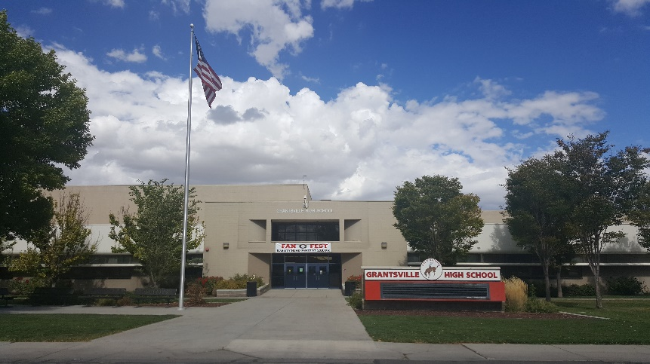They elected me as **president of the Grantsville High School Community Council** the next year. I had a good vice president, secretary and other members on the council. We accomplished a lot. One of the main things was the “AWARENESS DAY” for the school. A lot of work went into it. We sent a survey around the school to find out what types of workshops the students wanted. We came up with the following topics: FAMILY RELATIONSHIPS - LaDell Brown, Counselor for Tooele County, STRESS - Erick Krenz, a professor at the University of Utah, STAND UP FOR YOUR RIGHTS - Loretta Giebrink, Tooele County, SUCCESS, BYU athletes, CAREER’S - Elaine Jones, Professional Job Counselor, OVERCOMING HANDICAPS, ?, JUST A LITTLE BIT MORE POSITIVE”, Excellent movie, COMPUTORS, Hands on demonstration of Apple Computer. These workshops were repeated so that students could choose and take 2 of them. We then had a dating panel - a group from East High. After lunch the students could choose 2 of the following workshops: TEEN RECOVERED ALCOHOLIC - Brandon Creer, ODYSSEY HOUSE RESIDENTS, UTAH STATE PRISON INMATES AND SELF-INCOROPORTED, a teen improvisational theater troupe. They sent a prison inmate who shouldn’t have come. He told the students that he had embezzled $500,000 and hid it. He liked prison as they could eat wonderful food, play video games, pool, etc. There was a question and answer period and a student asked him if he would do it again if he had the chance and he told them “yes, wouldn’t you do it? I had a good vacation here in prison and when I get out I will get the money I hid and start my own business.” I didn’t hear this information directly as I was with the group “Odyssey House Residents” and the principal was with the inmate and that group in the auditorium, but members of the council, who had been in the auditorium with the prison inmate came to find me and told me what had happened and what was said. I was shocked and upset and asked if the principal didn’t stop it or do something about it - or the person who brought the inmate. She told me “no”. I ran to the auditorium to do something about it myself, but it had just gotten over and the students were leaving. I found the principal and asked him about it and why he hadn’t stopped it or said something to the students. He didn’t explain. I was so upset because he had left the impression that CRIME DOES PAY. I wrote a letter to the warden at the prison with a copy to go to the governor and to the principal. I received a letter of apology back from the warden, but I felt the damage had already been done. I was upset that the principal never did anything to try to undo the damage. I felt he was a WHIMP and I didn’t have much respect for him after that.

**The High School caught fire in February of that year and practically burned to the ground**. In most areas, it would be devastating if the high school burned down, but in our community, the building was a community center as well so it was really devastating for everyone. It happened at night. A boy was upset with his girlfriend who accepted a date for the school dance with another boy, so he started the garbage container on fire. He didn’t intend to burn the building down, but it was close to the school and it did catch fire. We woke up to the sound of sirens and the phone ringing. It was the principal. Since I was the High School Community Council President, he had called me. I quickly dressed and Ken & I drove down to the school. There wasn’t anything anyone could do.

**They had to have split sessions at the middle school**. The middle school students went from 7 a.m. to 12:00 and the high school students went from 1:00 to 7:00 p.m. Shellie was a Junior and was a cheerleader and Mike was playing football and in the band. David was also in the band. Scott was in the fourth grade and Jeff in kindergarten. It was a nightmare trying to keep everything going during those few months. I would take David to school, then Scott, then Jeff to afternoon kindergarten, then get Jeff and David and if we didn’t have enough cars, I would take Mike and Shellie and pick them up later. They had football practice and cheerleading practice and games so it was crazy trying to get them to everything and get them picked up. Sometimes their friends would bring them home. Trying to keep meals going for everyone was crazy also. One day Mom called and said her and dad were coming out to spend the day. I told her that I wouldn’t see them much because of my schedule for taking the children to and from school and activities. She said you can help me quit and dad can run the children back and forth. We did this and I had a relaxing day for a change. Dad would come in the house and say “who’s next and when do I take them?”

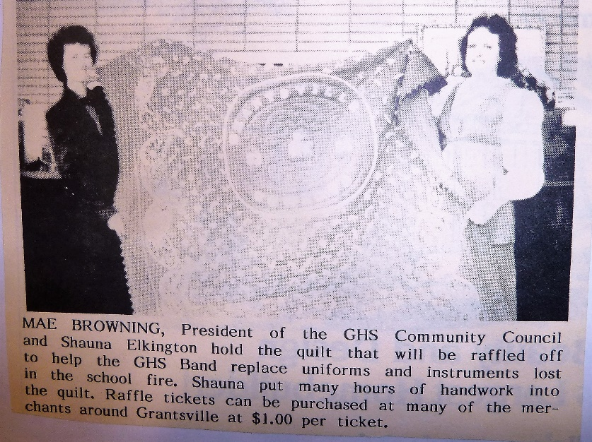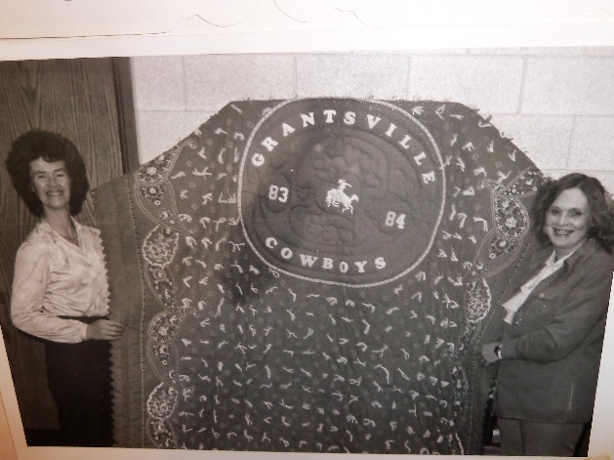**With being Community Council President I was also trying to do fund raisers with the council and community to raise money to buy new uniforms for the band.** We made a quilt and raffled it off, we had a dinner and sold tickets, etc. We did raise the money and the new band uniforms were beautiful. We were busy with other things also and by the end of that year, I was ready to move to Firth as I think I would have had a nervous breakdown if I had to go through another year like the last few months had been. And it did take another year to rebuild the high school. Shellie hated to leave her senior year, but didn’t feel it was so important since she would be going to the middle school again if she stayed.

One Sunday at Sacrament Meeting they announced that they needed **volunteers to usher at the Pioneer Memorial Theater in Salt Lake City.** I thought that sounded fun.

Ken was busy with being in the Bishopric so he didn’t feel he could take another night a week and go so I talked to a friend, **Betty Williams.** She liked the idea, so we called in. We took turns driving our car and the two of us had fun visiting on the way to and from Salt Lake. We really enjoyed ushering and after the play started, we could find a seat and watch it. That was great. My favorite play was “Annie”. I loved it all, but especially the songs. I can’t even remember the other plays. We ushered for the one season and it was great. We even saw some General Authorities. President Monson, who was at that time an apostle, came in with his wife. I was wishing I could have been their usher.

**South Willow Canyon** - When Sandi was still married to Dave Nix, we used to take the rest of our children and go camping with Sandi, Dave and the girls up South Willow Canyon which is south of Grantsville. It has some beautiful campgrounds. Dave wasn’t a very good husband or father, but he could cook great “Dutch Oven” meals, which we had up there. We usually just put down tarps then quilts and blankets and made a family bed for all of us. That was fun. Dave could be fun, but it was usually about Dave as he is a self-centered guy. He was always putting down Sandi, which was very hard on her self-esteem and hard on us to see him treat our beautiful and special daughter that way.

**Farmington Canyon** - We also camped with our children, including Sandi, Dave and their girls up Farmington Canyon. I can remember getting in a big water fight up there. Shellie loves water fights and she and Dave got into one. I’m not sure who got the worst of it, but most of us joined in too as it was a hot day.

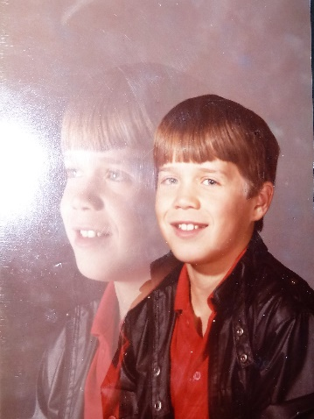 **SPOTLIGHT ON SCOTT BROWNING FOR PRIMARY NOV. 7, 1982** (Scott was 8 years old)

Scott Leon Browning was born in Mesa, Arizona on the 29th of January 1974. He was a husky little baby. In fact, the nurse who took care of him, said she would be very surprised if he didn’t turn out to be a good football player when he gets in high school because he had such strong muscles already.

His family moved back to Utah in 1976 so they could be near grandparents and other relatives as they had missed them. Scott and his family moved into the home in Sunset where his mother grew up so she had fun showing the children the places where her friends used to live, the schools which she attended, etc.

Scott is a happy child most of the time, but he has a temper like his great grandfather, so when he gets mad – look out. He does laugh a lot. Sometimes when he gets to laughing, he can’t stop and he laughs so hard that he rolls on the ground or floor and he gets everyone around him laughing hard also as they’re laughing at him.

When Scott was nine months old and he and his family were at Sacrament meeting, he started whistling. He just suddenly started to whistle. His parents were shocked and started stuffing crackers and other things into his mouth to keep him from disturbing the other people. But, whenever his mouth was empty, he began whistling again. The teenagers were pointing at him and smiling or laughing and lots of people came up after the meeting to see him and hear him whistle. From then on, he whistled a lot and we called him the “Happy Little Whistler.” Maybe he got that talent from his father and also his Grandmother Porter. They both whistled a lot.

Scott has a talent for gymnastics and he can turn a perfect cartwheel, stand on his head, do flips like stunt men do, etc. He also has a talent for music. Before he started taking piano lessons he made up songs or could pick out the songs on the piano by ear.

Scott is a good student in school, he enjoys baseball and other sports and horseback riding. He is a good help to his father on the farm. His parents are proud of him and love him very much.

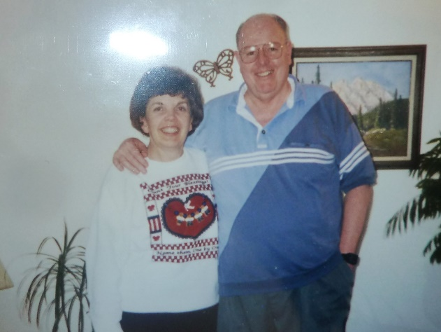 Ken and I had some **good friends** in Grantsville, especially **Allen & Jeanie Burgess**. We got together at each other’s homes and played games or we would go out to eat together. When we moved, we stayed in touch, but we couldn’t do much together as we moved to Firth, Idaho for two years and then back to Arizona for 9 months, then we moved back to Utah and moved in with Ken’s mom. We were there for almost four years, but when we bought our home in Layton, the four of us did more together again. We would take turns going to each other’s homes to play games, but we would go out to eat first. We loved being with them, they were such great friends and good people. Allen had been a Bishop, stake counselor, and the best Gospel Doctrine Teacher that I have ever had. He made the lessons come alive. Part of it was because he was a seminary teacher and the seminary principal. He asked me to teach his classes one day and gave me the subject. He was going to be there, but he wanted his students to be taught by me. I was really nervous, but I accepted. I studied hard and had good visual aids. I fasted and prayed and the Lord surely blessed me. It turned out really good and Allen praised me for the great job I had done. Allen taught “Know Your Religion” classes at the seminary building on Thursday nights, and I went to as many of the classes he taught as I was able to. I loved them. Allen died at a young age – in his 60s. Jeanie had gone in to wake him up as we hadn’t heard him in the shower. She tried to wake him, but he was dead. He must have died of an aneurism. He had had brain cancer and been operated on earlier and it seemed that he was fine again, but guess not. Jeanie was too scared to live alone, so she sold her beautiful home in Grantsville and moved in with her daughter, Becky and her husband. They ended up selling their home and building a new home for all of them. It worked out well and Jeanie loved being with her family. She kept busy making quilts for the church humanitarian service and later she became a missionary helping members with Family History. Jeanie had been a Relief Society President as well as many other positions. I taught their two oldest sons in Primary and then in Sunday school. I made small birthday cakes for the kids on their birthdays and took it to them. I taught the oldest Primary class before they went into scouting and YM & YW. I had to work with the boys on a one-to-one at our home to make sure they were caught up on all they needed before they turned twelve. I got to know their two sons, as well as the other boys, really well this way and I enjoyed it. Jeanie and Ken and I have stayed in touch, especially with Christmas letters and pictures. She invited us to her youngest son’s wedding reception last summer (2016). He was in his 30s, but married a beautiful girl in the temple. It was so good to visit with Jeanie, Becky & her husband and the two other sons. Brian, the younger son who I taught in Primary, came and visited with us while we ate and it was fun reminiscing.

Some ladies were thinking of “home schooling” their children because of the language, bullying, etc., at the schools. I was thinking about it too, but Ken thought it would be too much for me with everything else I was doing. He asked Allen what he thought and he said “If all the good kids were taken out of the public schools, what would happen to the other kids. They need the influence and example of good kids.”

Shellie had a hard time moving again and trying to make friends here in Grantsville. Some girls befriended her, but it was the wrong crowd. I knew Jeanie & Allen had a daughter who was Shellie’s age so I told Jeanie about Shellie and she told Becky. Becky saw Shellie in the cafeteria at school and asked her to come eat lunch with her, and they became good friends. The other friends saw her with Becky and told her to come with them, but she refused and I’m sure glad she did. She wasn’t happy with these other girls anyway.

**Four Corners (Utah, Colorado, Arizona & New Mexico)** – Sandi, Dave & their girls went with our family. We borrowed Mom & Dad’s RV. We saw Indian Ruins, went into Durango & Telluride and camped in the beautiful forest in Colorado. We had a great time. A deer tried to climb into the RV. (We have a DVD with the deer doing that). One funny thing was that Chelci climbed a tree and when our son, David, saw her, he was afraid for her and hurried over and helped her down. We laughed about that as when David was four years old, he wasn’t afraid of anything and he climbed a high pine tree when we were setting up camp at Island Park and called down to us to see him as he was swinging the top of the tree back and forth.

We were there in Grantsville for four years when the **church consolidated the farms** and had one farm manager over all the farms, and the other farm managers were just farm help. Vern Pankratz had been a farm manager 6 months longer than Ken so he was chosen to be the farm manager. Since we were not making much money, and now there was no incentive for Ken, and I was burned out from all the work and problems of this past year, and Irven had talked us into coming to Idaho and going into business with him in the A L Williams Insurance Company, we moved to Firth, Idaho.